Gate 05 - Playwright Advanced

Participant: Sankaran Selvaraj
Date: 04-07-2026
Project: Week05_Playwright_advanced
1. Objective
The objective of this project is to learn and implement advanced Playwright concepts by creating stable and reliable automated tests.
In this project, I worked on:
- Fixing flaky UI tests
- Testing refund APIs
- Validating money calculations using paise
- Testing offline scenarios
- Preventing duplicate refunds using Idempotency-Key
- Collecting execution evidence like videos and reports
The main goal was not just to make the tests pass, but to understand the root cause of failures and fix them properly.
2. User Stories
User Story 1 – Login
As a customer, I should be able to log in successfully without random failures.
Acceptance Criteria
- Login page opens.
- User enters email and password.
- Sign In button is enabled before clicking.
- Login completes successfully.
User Story 2 – Refund
As a customer, I should receive the correct refund amount.
Acceptance Criteria
- Full refund works.
- Partial refund works.
- Over-refund is rejected.
- Duplicate refund requests are prevented.
User Story 3 – Offline POS
As a POS user, queued sales should sync automatically after the internet connection is restored.
Acceptance Criteria
- Offline banner appears.
- Sale is added to queue.
- Queue syncs after reconnect.
- Sale is not duplicated.
3. Project Structure:
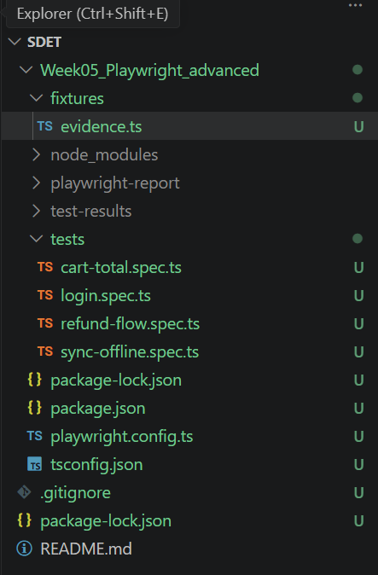
4. Test Cases:
Login Stabilization
This module verifies the login functionality under different conditions. It includes a flaky login test to demonstrate how timing issues can cause intermittent failures and a stable login test that uses Playwright Web Assertions to wait until the Sign In button is ready before clicking. This ensures the login process is reliable and consistent.
Before:
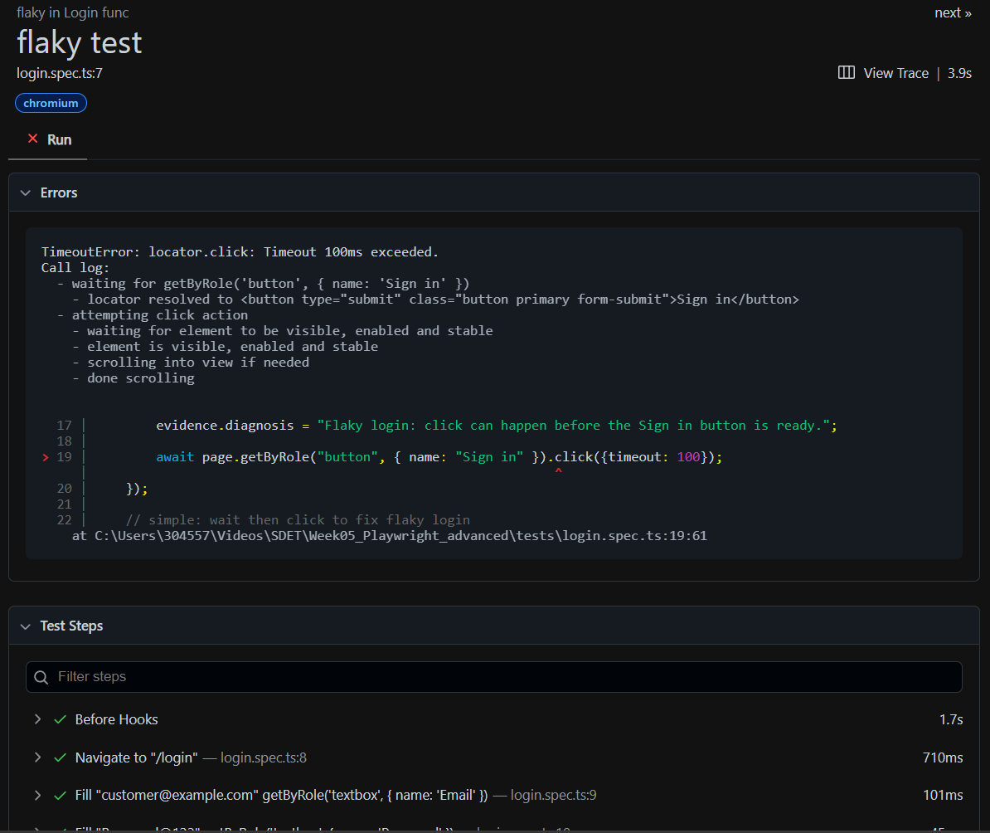
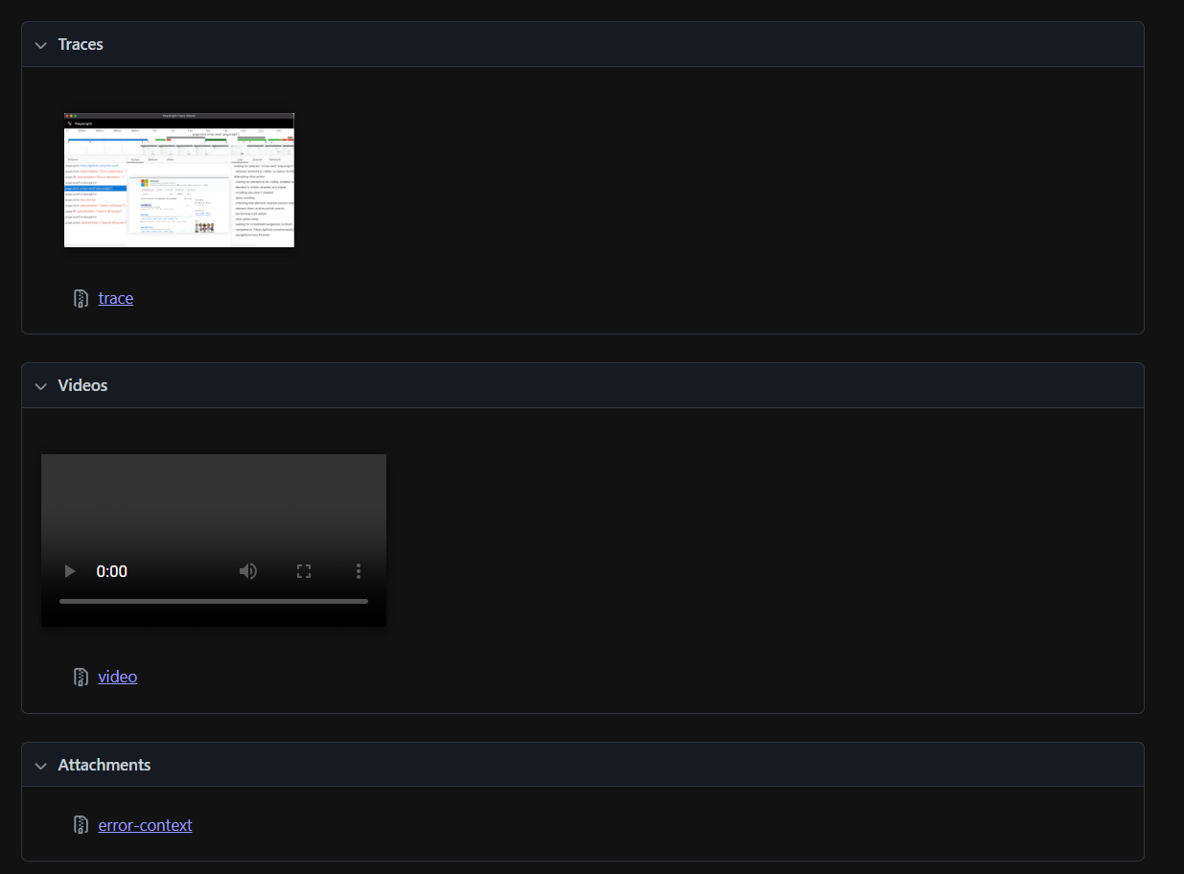
After Fix:
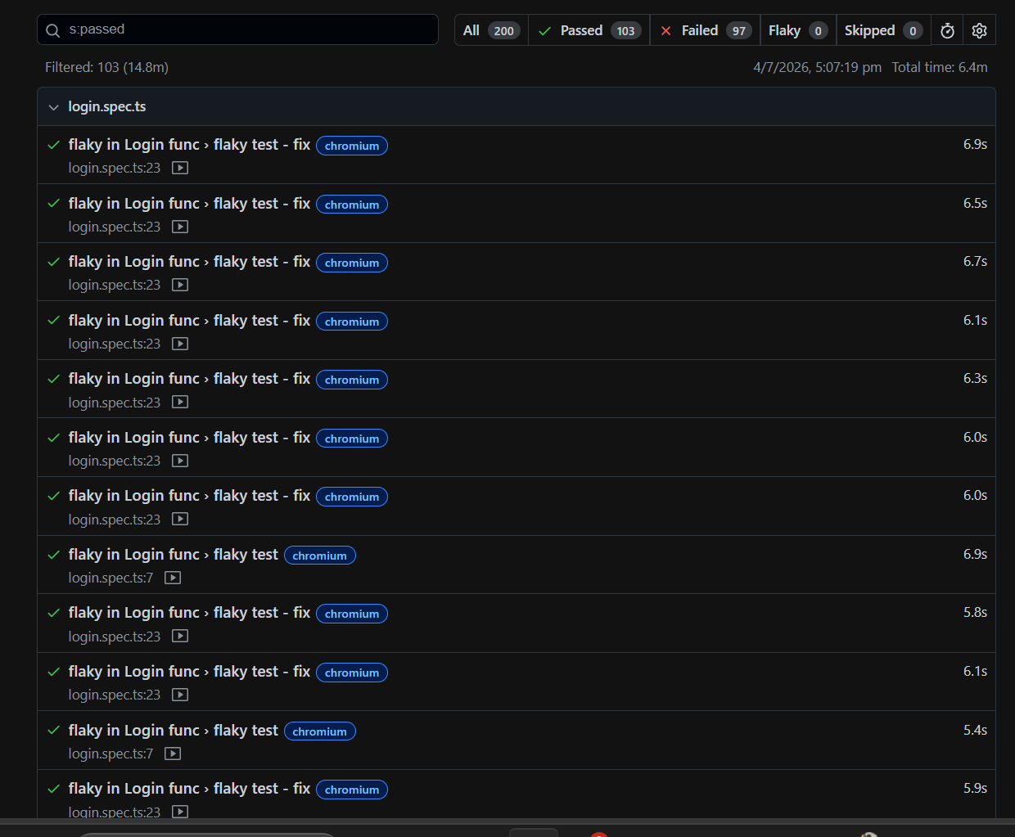
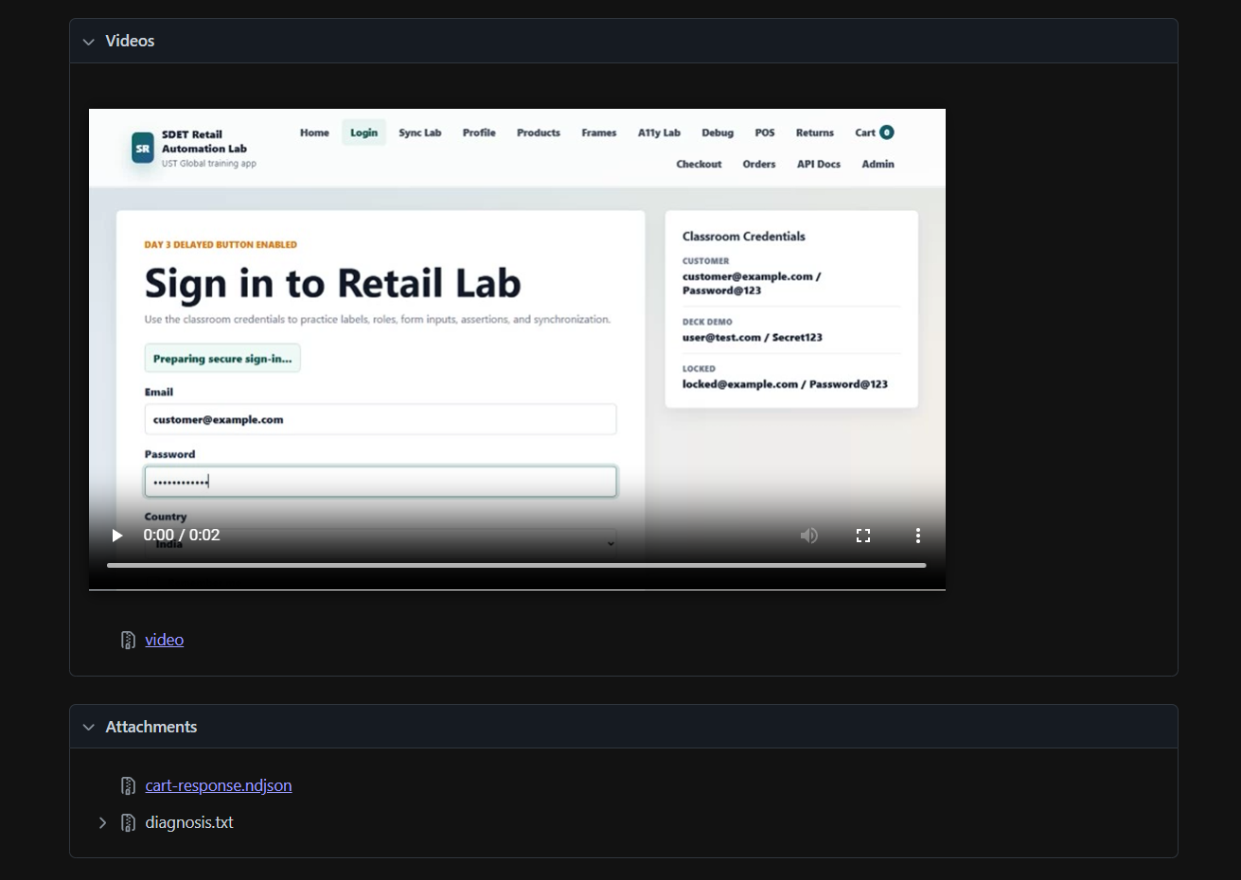

Offline Synchronization
This module verifies how the application behaves when the network connection is unavailable. It checks whether the offline banner is displayed, confirms that failed synchronization rolls back the pending sale correctly, and ensures that queued sales are synchronized automatically after the network connection is restored without creating duplicate records.
Before flaky:
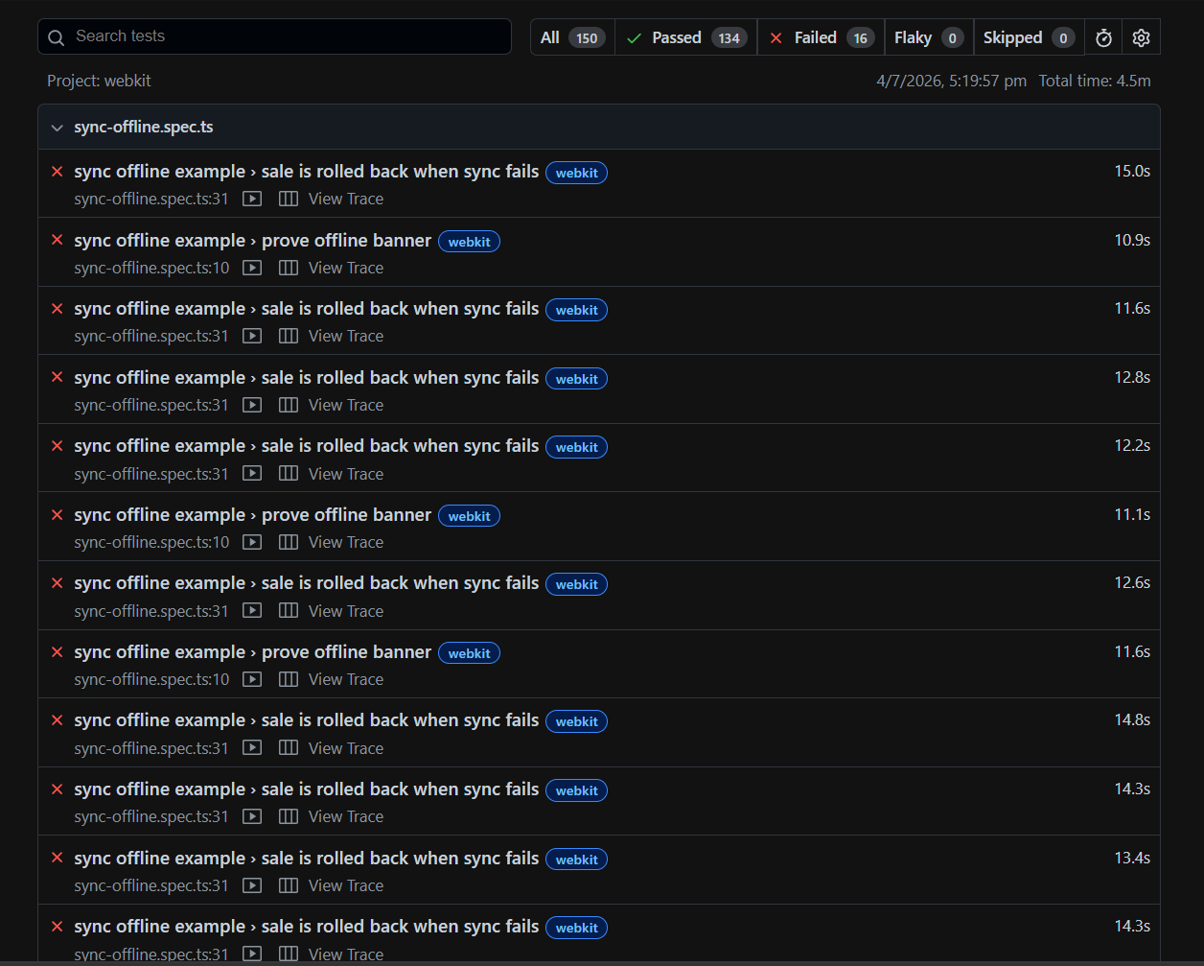
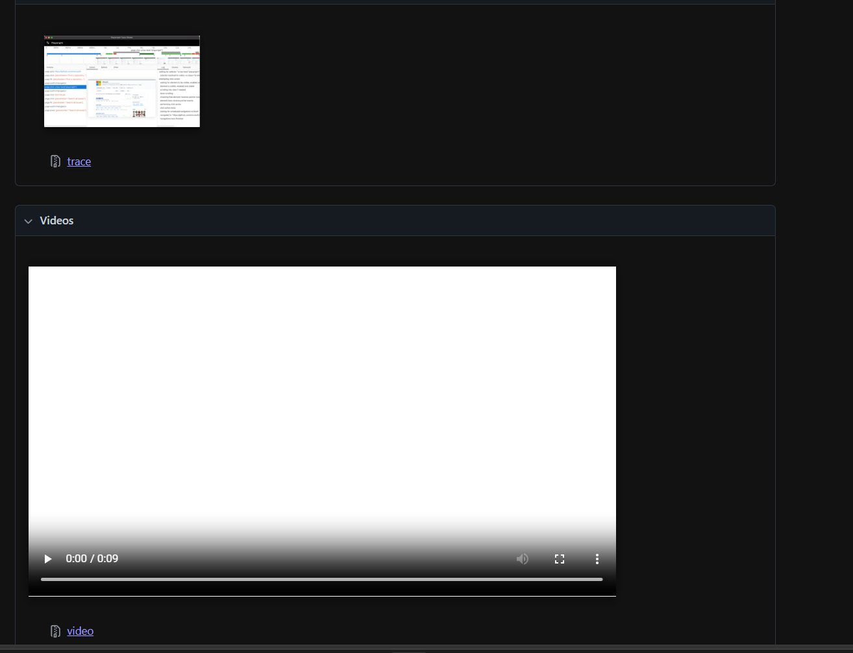
After fix:
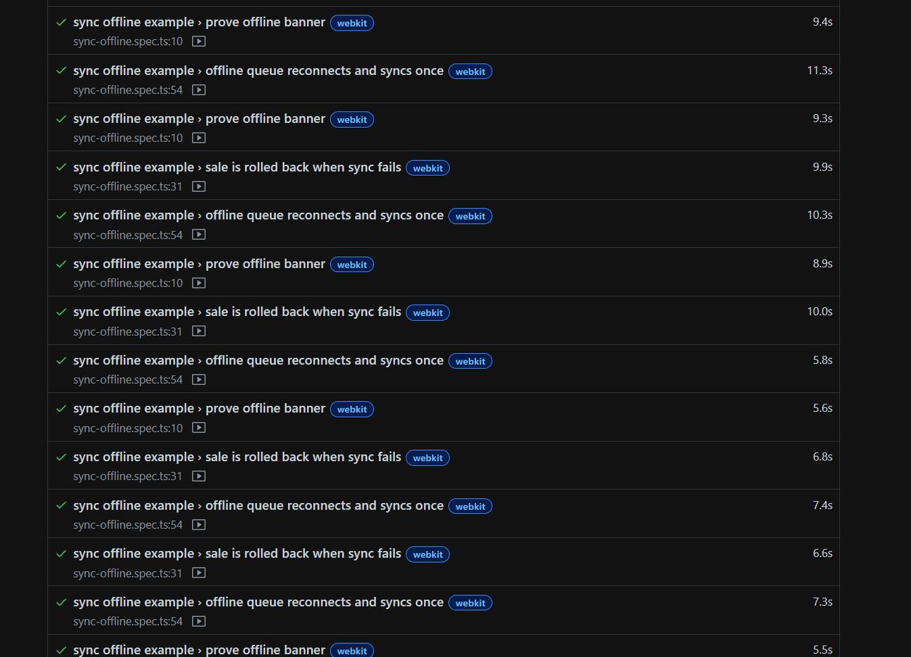
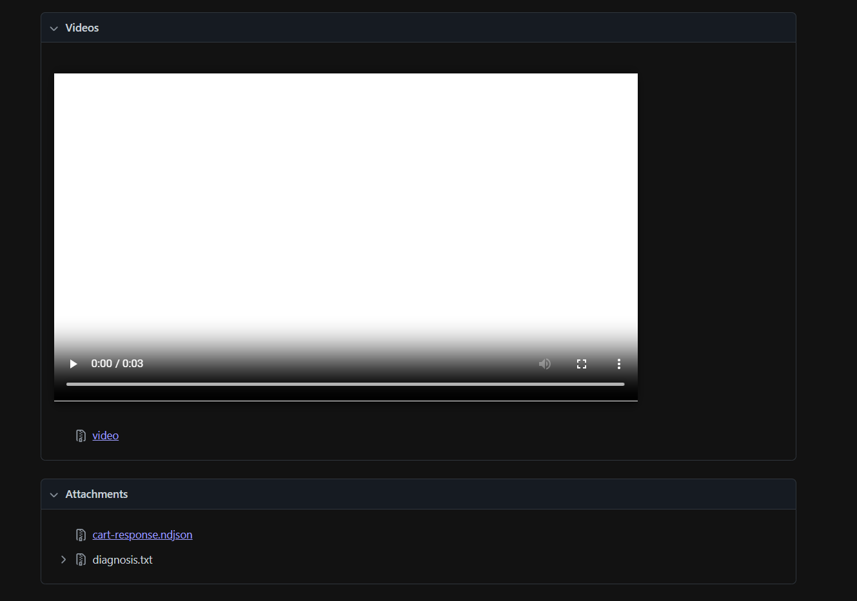

Refund Flow
This module verifies the refund functionality by covering different business scenarios. It tests a full refund to ensure the complete order amount is refunded, a partial refund to validate the refund amount and tax calculations in paise, a rejected refund to ensure the system blocks refund requests that exceed the purchased quantity, and an idempotent refund to verify that sending the same refund request multiple times with the same Idempotency-Key does not create duplicate refunds.
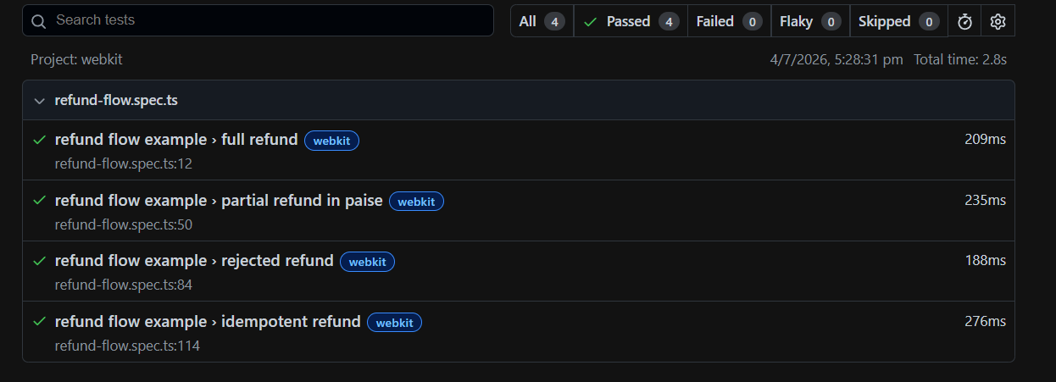
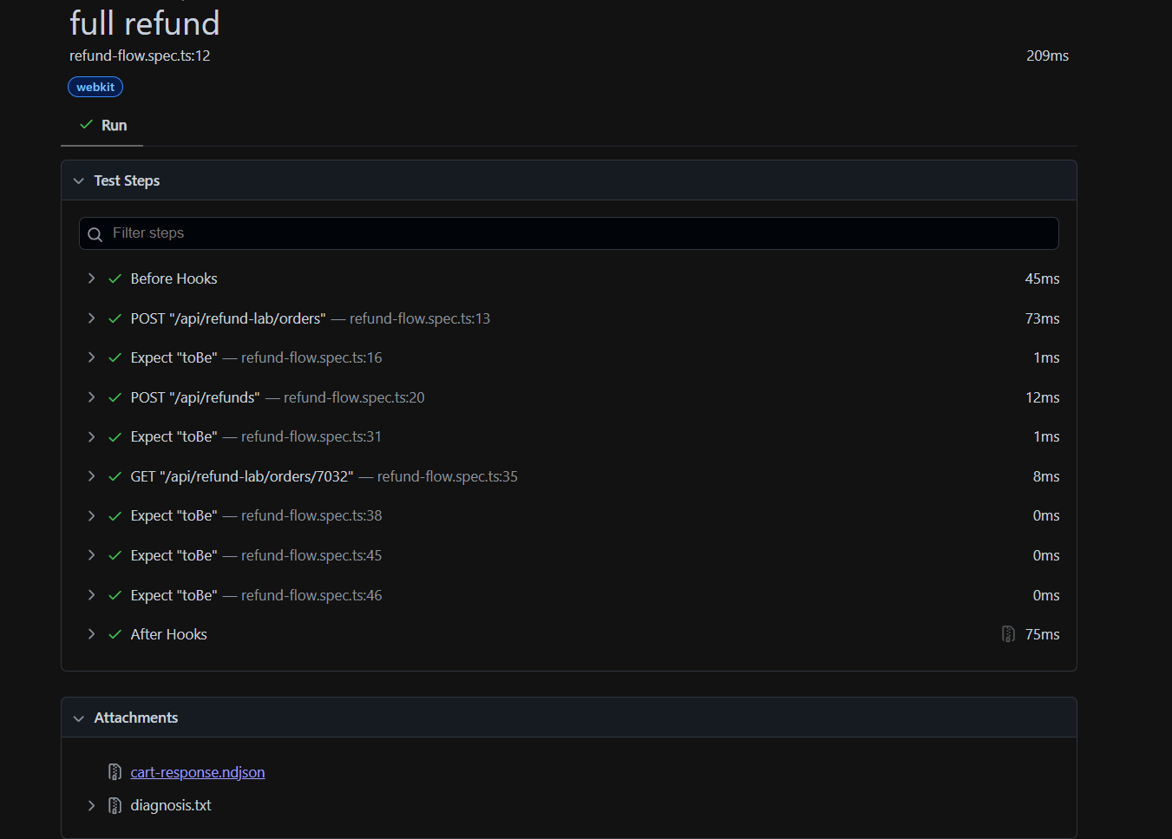

5. Evidence Collection
I created a custom fixture called evidence.ts.
It stores useful information after every test, such as:
- API response
- Diagnosis message
- Video
- HTML Report
- Trace
This makes debugging much easier.
6. Stabilisation Approach
During this project, I followed three simple steps.
Find the real problem
Instead of hiding failures with delays, I found the actual reason for each issue.
Apply the correct fix
I used Playwright best practices like Web Assertions and proper validations instead of hard waits.
Collect proof
Every test generates reports, traces, videos, and evidence so the results can be verified easily.
7. Conclusion
This project helped me understand advanced Playwright concepts in a practical way. I implemented stable UI tests, tested refund APIs, handled offline scenarios, and collected execution evidence using custom fixtures.
Instead of making tests pass by adding delays, I focused on finding the real cause of failures and fixing them correctly. This approach makes the automation more reliable, easier to maintain, and closer to real-world testing practices.

